Overview  Country: South Africa  Industry: Information Technology  Customer Profile  The AST Group is an information and communications technology company with more than 60 offices and service centers in the southern African states.  Business Situation  Proposals often did not match the customer deliverables at project completion. To demonstrate its process consistency, AST required a closer correlation between the two stages.  Solution  AST’s Microsoft® Solutions division deployed the Microsoft Office Enterprise Project Management (EPM) Solution to increase information availability and consistency from proposal phase to project completion.  Benefits  - Meeting customer project milestones  - Ensuring profitability on fixed-fee projects  - Showcasing the Microsoft Office EPM Solution for customer deployment  - Reducing meeting time by 80 percent  - Gaining flexibility for growth |  |  | “We’ve cut our weekly project management meeting time by 80 percent. Resources are also allocated better, and the relationship of materials to projects is known, eliminating surprises on projects.”  Mari Gaertner, Business Unit Manager, Solutions Division, AST Group
 |  |  | As an emerging leader in the highly competitive information and communications technology industry, the South Africa–based AST Group found itself facing some of the same project management challenges as its customers and trying to sustain a high growth rate in a weak economy. The AST Group sought to help its IT Solutions division manage customers’ projects more effectively and improve information consistency from a project’s proposal to its completion. AST deployed the Microsoft® Office Enterprise Project Management (EPM) Solution. The company’s Microsoft Solutions business unit embedded the Microsoft Office EPM Solution in the AST Group’s myAST portal. Now, AST is better able to meet project milestones and ensure profitability on fixed-fee projects. The company also has cut meeting time for projects by 80 percent.
 |  |  | 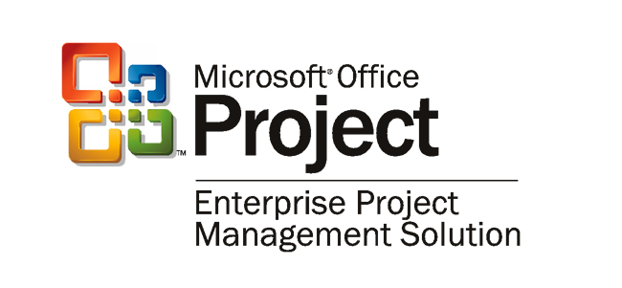

Situation
In just three years, the fast-growing AST Group became one of the top three companies in the South African information and communications technology (ICT) industry. Its world-class physical infrastructure gives it the capability to serve companies of any size—from small firms to the largest corporations. With 14 mainframe processors, more than 200 UNIX servers, and more than 3,000 Intel-based customer server platforms, the company supports more than 265,000 connected devices that serve more than 60 offices and service centers across southern Africa.
“Project visibility, provided at a portfolio level, gives our managers the ability to identify at-risk areas within their respective portfolios.”
Johan Smook, Chief Operating Officer, Solutions Division, AST Group

“By wisely placing our offices and service centers close to our customers, AST is positioned to provide better value, be more responsive, and offer outsourcing and business consulting, as well as technology solutions,” says Johan Smook, Chief Operating Officer in the AST Group’s Solutions division. “This proven strategy incorporates customer care with the plan-build-run-leverage cycle of technology solutions, which has found favor internationally.”

Focusing its 3,800 ICT professionals worldwide on assisting their customers’ growth and efficiency, the company wanted to provide more consistent information from project concept to completion for its customers in financial services, healthcare, mining and manufacturing, telecommunications, and government. “Inconsistent information gives customers something to worry about, because it causes confusion about deliverables, schedules, and other aspects of project management,” says Smook.

To create business value for its customers, AST supports them through the entire life cycle of ICT solutions and across the full spectrum of ICT environments with its software solutions. Expert in driving down the total cost of ownership, AST uses similar techniques to improve service levels by exploiting economies of scale, implementing continuous improvement, and applying best practices.

“The growth of AST’s professional services organization has increased the demand for timely and consistent information pertaining to business operations,” says Smook. “The burden of administering projects and the pressure to deliver projects faster and more profitably put project and business managers under increasing pressure to spend their time more productively.”

“Because of weak economic conditions and budget constraints, many of our customers are requesting fixed-fee projects,” says Mari Gaertner, Business Unit Manager in the AST Group's Microsoft Solutions division. “To do this well, we must have consistent data from project proposal through every milestone deliverable until the end of the project—or we can lose money.”

AST’s project managers worked in a stand-alone environment using previous versions of Microsoft® Project to manage their project schedules. Meanwhile, the billable time that managers worked was captured in a separate timesheet system, the myAST user portal. And project profitability information, as well as invoicing, came from an SAP enterprise resource planning (ERP) solution. Managers used data from all these systems to provide reports to customers—but the data in the timesheet solution often failed to match project-task activities derived from Project, which, in turn, did not match SAP data. This forced managers to spend significant amounts of nonbillable time to correlate the data. Furthermore, management did not have sufficient visibility into project information to manage its business.

Solution
To improve consistency throughout the project cycle and across the various platforms being used, AST’s IT Solutions division turned to its Microsoft Solutions business unit to help implement the Microsoft Office Enterprise Project Management (EPM) Solution based on Microsoft Project Server 2003, part of the Microsoft Windows Server SystemTM integrated server infrastructure software. The Microsoft Office EPM Solution is integrated into the company’s myAST user portal, whose components include electronic forms and a workflow suite developed to automate key business functions. The integration of the EPM Solution into myAST resulted in the myAST.EPM solution.
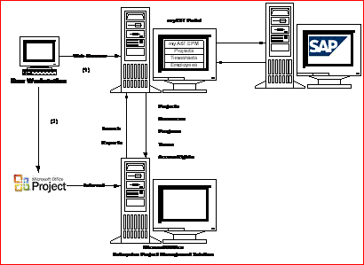
Figure 1. AST’s myAST.EPM is loosely coupled to allow maximum flexibility. It provides two ways to access project data.

By developing a custom software application to communicate seamlessly with AST’s SAP system, the workflow suite helped AST to increase productivity by automating human-to-human and human-to-system workflow and business processes. For knowledge management, AST uses Microsoft Windows® SharePoint® Services in the Microsoft Windows ServerTM 2003 operating system. The company plans to incorporate Windows SharePoint Services functionality into the EPM Solution environment.

Integrating EPM into the Line-of-Business Solution
“The implementation of EPM within the AST operational environment required a significant level of integration. Microsoft Project Server 2003 increased our ability to integrate the EPM Solution successfully with AST’s line-of-business systems,” says Jacques Viljoen, EPM Lead for AST’s Microsoft Solutions business unit. “myAST.EPM is a critical component enabling the AST Service Process Optimization environment.”

Specifically designed to operate as its own application, myAST.EPM is loosely coupled with the SAP environment by using an asynchronous batch interface. This design allows easy integration with other ERP environments to ensure data continuity and flexibility for future extension of the solution. The myAST portal, which houses myAST.EPM, makes it easy to download projects, resources, timesheets, and related information into the EPM Solution for additional reporting, analysis, and planning. The portal also provides a common project view for communication. (See Figure 1.)

Data is passed among the SAP, myAST portal, and myAST.EPM environments as XML that all three parts of the solution can use. The solution uses the SAP Distributed-Component Object Model (DCOM) Connector, a standard SAP Business Application Programming Interface, to pull information from SAP into the business object layer of the myAST portal. Data is synchronized on a daily basis and whenever a new project is created or a new employee is allocated to a project.

The integrated billable-time reporting that AST sought is provided by the architecture shown in Figure 2. The project manager and team members capture time in the myAST database, and the project manager also captures related information, such as budgeted hours for specific tasks. A download program brings this data into the EPM environment. The Project Server 2003 object model and project data services convert the data so it can be used by myAST.EPM and then push the data into the EPM database. From there, users can view the data either through the EPM user interfaces—Microsoft Office Project Web Access and Microsoft Office Project Professional 2003—or through custom myAST.EPM reporting views.

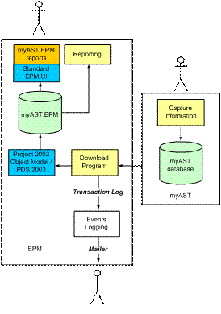
As data passes through the download program, it also passes through an events logging application that monitors the status of the data flows. If there is a system disruption or other problem, the events logging application notifies IT managers automatically, making it possible for them to ensure availability of the solution to the project managers who rely on it.

The SAP-myAST integration was originally written with the Microsoft Visual Studio® version 6.0 and the Microsoft Visual Basic® version 6.0 development systems. As the solution expands, AST plans to migrate myAST code to the Microsoft .NET Framework to take advantage of its native support for Web services as an integration medium.

The myAST.EPM solution currently runs with Project Server and Windows SharePoint Services on a single server. The database portion of the solution, supported by Microsoft SQL ServerTM 2000, runs on a separate server. As AST expands its use of the solution, it can easily scale up SQL Server 2000 to additional machines.
Figure 2. Billable-time data captured in the custom myAST solution is downloaded into the EPM Solution and converted into formats that users can view through standard EPM interfaces or reports.

AST is also contemplating expanding the solution by migrating to Microsoft SharePoint Portal Server 2001 to gain its document indexing and searching functionality. The company could easily support an expanded solution by running Project Server and SharePoint Portal Server on separate servers.

To help plan the highly customized EPM Solution design, AST took advantage of the Microsoft Solutions Framework (MSF) design principles and best practices. To facilitate deployment, AST followed the EPM Enterprise Implementation Framework (EIF).

“The Microsoft Office Solution Accelerator for Enterprise Project Management provided an important guideline for a quality deployment,” says Viljoen. “That was especially helpful to us, given the special integration needs of our solution.”

Using the EPM Solution
AST’s Solutions division uses a fully integrated project registration cycle. When starting a project, an AST Solutions project manager accesses predefined templates that adhere to AST’s methodology. These templates are then saved so other project managers and team members can use them to ensure continuity across the project. The reuse of templates improves information consistency for the company, saves time, and improves efficiency for workgroups.
“Microsoft Project Server 2003 increased our ability to integrate EPM successfully with AST’s line-of-business systems.”
Jacques Viljoen, EPM Lead, Microsoft Solutions Division, AST Group

Users access the myAST.EPM solution through Project Web Access views incorporated into a Web application or through Project Professional 2003. Project Web Access gives project managers a highly visual interface into their data, and executive managers use dashboard views to track data at a high level. With a reports link in Project Web Access, users can easily call reports from myAST. Project Professional gives project managers an interface to initiate projects, do planning, review billable time captured by the myAST portal, and integrate that data with budget information originating in SAP.
Figure 3: AST project and portfolio managers can access detailed project views with the Microsoft Office EPM Solution.

Because myAST.EPM can extract information from the SAP system, this solution improves overall efficiency and project information consistency. By using the rich reporting environment provided by the myAST.EPM interface—including a series of red, yellow, and green lights-like graphics—project managers can assess project risks and identify problem areas earlier. The reporting information is also used to enhance detailed status reports for AST’s customers. The download-environment view shows project status information, so AST portfolio managers can view the status of critical projects within each of AST’s business units. (See Figure 3.)

Currently, AST’s Solutions division tracks about 40 active high-risk projects and manages 300 resources. The project figure varies, as finished projects are stored in a knowledge base for future project proposals. Three divisions—Application and Integration Solutions, Manufacturing Systems Integration, and Microsoft Solutions—and about 12 project and portfolio managers, 10 outside contractors, and 4 executives now rely on the system. The number of users is expected to approach 250 soon, with an anticipated 50 project and portfolio managers.
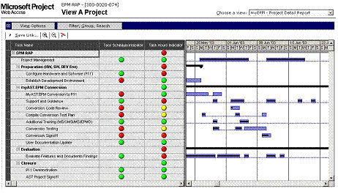

An online methodology guide, myAST.Methods, captures best practice processes, templates, and deliverables, including the EPM Solution templates for different types and sizes of projects, system development life cycles, and delivery technologies. For example, a custom project guide collects the Microsoft Solutions business unit’s best practices.

“Ideally, we’d like our proposal process to be pulled from our past experience on similar projects and to incorporate our best practices for estimating and scheduling. We want the proposal to reflect a project accurately from start to finish,” says Gaertner.

Benefits
myAST.EPM at a Glance
Total users | 200
Concurrent users | 40
Team members | 120
Resource manager users | 2
Executive users | 4
Active projects expected | 40
Average project duration | 3 months
Largest project expected | 6 months
Timesheet reporting | Weekly
Standard project templates | 3

The EPM Solution makes it possible for AST to meet customer milestones and ensure profitability on fixed-fee projects, sell the EPM Solution to its customers, reduce meeting time for projects by 80 percent, and gain the benefits of flexibility well into the future.

Meeting Project Milestones
“AST is a project-centric company, requiring the ability to identify project risks such as overruns as early as possible,” says Smook. “On a fixed-bid project, every milestone we miss means lost revenue. Project visibility, provided at a portfolio level, gives our managers the ability to identify at-risk areas within their respective portfolios.”

The increased project visibility provided by the EPM Solution means that project managers can administer their projects with greater discipline and track project progress in more detail. In addition, portfolio and project managers gain business insight by identifying problems in high-risk projects sooner. “Making our project effort more visible has been very positive,” says Smook. “The project managers know exactly what’s happening and are able to do more detailed tracking.”

Demonstrating the Solution in Action
Customers can see how AST captures information in its external timesheet system and how the actual information is reflected in its EPM status reports. “Seeing the AST Group’s EPM solution helps sell customers on their own EPM implementations,” says Viljoen. “Our projects are all done on our customers’ behalf, so this system helps them understand the type of consistent reporting we can provide them throughout their projects.”
AST’s customers can observe firsthand how AST project teams view project and portfolio information to show projects that are at risk. “By using our own solution, we now have a showcase EPM Solution for our customers,” Viljoen says. “And we’ve experienced firsthand what a customer deployment involves. We understand our customers better, we can better address their needs, and we can build a more successful relationship with them.”

Cutting Meeting Time by 80 Percent
“We’ve cut our weekly project management meeting time by 80 percent,” says Gaertner. “Resources are also allocated better and the relationship of materials to projects is known, eliminating surprises on projects.” In addition to being more efficient and managing resources better, AST is creating more professional-looking proposals, and the consistency of information from proposal to project completion has improved.

Flexibility to Extend the Solution
AST plans to not only use its EPM implementation to align and prioritize its own future projects, but also to extend the system in other ways, including creating higher levels of integration with its existing systems. The loose coupling with SAP systems makes this possible by enabling AST to take advantage of its existing systems investment, while also giving the company the agility to integrate with other systems—those currently deployed or those that may be deployed in the future—whenever it makes business sense to do so.

The company is exploring the feasibility of using the EPM Solution to perform project setup for resource assignments within its Web-based myAST.Eforms. Project teams are investigating expanding the use of enterprise project templates and project guides within the organization and using the collaboration features.

“The use of linked documents, and risk and issue management features are other areas we want to explore,” says Viljoen. “Because of our portal approach with myAST, continuing future EPM enhancements can evolve more quickly.”

The Microsoft Office System
For More Information
For more information about Microsoft products and services, call the Microsoft Sales Information Center at (800) 426-9400. In Canada, call the Microsoft Canada Information Centre at (877) 568-2495. Customers who are deaf or hard-of-hearing can reach Microsoft text telephone (TTY/TDD) services at (800) 892-5234 in the United States or (905) 568-9641 in Canada. Outside the 50 United States and Canada, please contact your local Microsoft subsidiary. To access information using the World Wide Web, go to:
www.microsoft.com

For more information about AST Microsoft Solutions products and services, call +27 (12) 675 5000 or visit the Web site at:
www.ast.co.za

For more information about AST Group products and services, call +27 (12) 675 5000 or visit the Web site at:
www.ast.co.za/home

© 2004 Microsoft Corporation. All rights reserved. This case study is for informational purposes only. MICROSOFT MAKES NO WARRANTIES, EXPRESS OR IMPLIED, IN THIS SUMMARY. Microsoft, the Office logo, SharePoint, Visual Basic, Visual Studio, Windows, Windows Server, and Windows Server System are either registered trademarks or trademarks of Microsoft Corporation in the United States and/or other countries. The names of actual companies and products mentioned herein may be the trademarks of their respective owners.

Document published September 2004

Software and Services  - Microsoft Office Enterprise Project Management Solution  - Microsoft Office Project Server 2003  - Microsoft Office Project Professional 2003  - Microsoft Office Project Web Access  - Microsoft Windows Server System  - Microsoft Windows Server 2003, Enterprise Edition  - Microsoft Windows 2000 Server  - Microsoft SQL Server 2000  - Microsoft Visual Basic version 6.0  - Microsoft Visual Studio version 6.0 | - Solutions  - Microsoft Office Enterprise Project Management Solution  - Microsoft Office Solution Accelerator for Enterprise Project Management  - Microsoft Solutions Framework  - Technologies  - Microsoft Windows SharePoint Services  Hardware  - AMD Athlon clone server

Microsoft Office is the business world’s chosen environment for information work that provides the software, servers, and services that help you succeed by transforming information into impact.

For more information about Microsoft Office System, go to:
www.microsoft.com/office

